Implementation and Evaluation of Dexamethasone Pulse Therapy Compared to Prednisone Therapy as a First Line Treatment for Idiopathic Inflammatory Myopathies
Marlies Verhoeff
Academic Medical Center
Amsterdam, The Netherlands

Senior and Daily Supervisor
Prof. Dr. M. De Visser
Department of Neurology
Telephone:020-65563445
Academic Medical Center
Amsterdam, The Netherlands

July 5, 2013
Abstract
To evaluate the implementation of dexamethasone pulse therapy as a first line treatment for idiopathic inflammatory myopathies (inclusion body myositis excluded) in a third referral center a retrospective study was performed.
We recorded patient characteristics, treatment data, clinical outcome (muscle strength, disability, treatment failure), second line medication and side effects, and serum CK activities at 2-4 months, 4-6 months and 8-12 months.
The high-dose dexamethasone pulse therapy did not differ from the conventional prednisone therapy in functional outcome at the time point of 12 months after inititation of therapy. Patients treated with dexamethasone were significantly more often without any medication after 12 months. Eighteen percent of the patients treated with either dexamethasone or prednisone are on other immunosupressive therapy after 12 months.
In conclusion, dexamethasone pulse therapy has been implemented as a first line treatment and was beneficial for a proportion of the patients. However, prognostic factors to determine which patient are responsive are urgently warranted.

1 Introduction
Idiopathic inflammatory myopathies (IIM) are auto-immune diseases characterized by sub-acute onset, proximal, symmetrical muscle weakness and mononuclear cell infiltrates in the muscle biopsy, necrotising auto-immune myopathy excluded(1). The low prevalence of IIM makes it difficult to study this disease and the efficacy of the treatment(2). The natural course of IIM is based on retrospective studies and shows that 20% of the patients has a monocyclic disease course, 20% a polycyclic disease course and in 60% the disease course is chronic continuous(3).
First-line treatment is high-dose prednisone (HDP)(4,5). In general when remission is achieved, tapering takes place, but in most cases a maintenance dose is needed. Since high-dosage prednisone causes serious side effects(6), there have been numerous attempts to evaluate the efficacy of novel treatment modalities. In the treatment of idiopathic thrombocytopenic purpura (ITP) high dose dexamethasone pulse therapy (HD-DPT) was shown to be effective(7). There was an 85% response rate and the high-dose dexamethasone was well tolerated, with few adverse effects. A retrospective study on patients with ITP(8) revealed that HDP caused a significantly longer duration of response than HD-DPT, but the efficacy of the two treatments was the same and none of the patients experienced long term adverse effects. In a randomized controlled trial (9) HD-DPT proved to be more effective as compared to HDP as first-line treatment of ITP, with less relapses and adverse events.
More evidence in favor of dexamethasone pulse therapy was found in a Cochrane Review on the treatment of chronic inflammatory demyelinating polyradiculoneuropathy (CIDP)(10). Effectiveness was the same as with conventional prednisone treatment. However, two of the side effects that were reported (i.e sleeplessness and moon facies) were significantly less common in the dexamethasone group. Furthermore, there was a trend that improvement of dexamethasone-treated patients was more rapid than in the control group(10).
In a randomized controlled trial (RCT) HD-DPT and prednisone therapy showed similar effectiveness and safety in idiopathic inflammatory myopathies (sporadic inclusion body myositis excluded), i.e., nonspecific myositis, dermatomyositis and necrotizing auto-immune myopathy(11). There was no difference in the effectiveness of the two treatments, although patients treated with prednisone therapy experienced a significantly later relapse (60 (2.9) weeks) as compared to the dexamethasone group (44 (4.7) weeks). However, HD-DPT caused significantly less side effects, suggesting that it is a good alternative to the conventional prednisone therapy(11).
Based on these results, we changed our treatment policy from high-dose prednisone therapy to high-dose oral dexamethasone pulse therapy. This study retrospectively evaluates whether HD-DPT was implemented as first line treatment and if the results were in line with the results from the RCT(11).

2 Patients and methods

Patients
The medical records of all patients diagnosed with myositis between 1999 and 2013 at the neurology clinic of the Academic Medical Center (AMC) of Amsterdam, a third referral center for myositis were examined. Patients diagnosed with dermatomyositis (DM), non-specific myositis (NSM) and necrotizing autoimmune myositis (NAM) who were diagnosed after the termination of the Dexa-Myositis trial (2008) were included in the standard group. Patients who participated in the Dexa-Myositis trial were included in the control group(11). In order to perform statistical tests on a larger sample, the standard group and the control group were taken together. The results from the standard group alone were compared to the results in the combined group (the complete sample). Diagnostic criteria for the three subtypes were as follows: all three subtypes must show the characteristic clinical features consistent with an idiopathic inflammatory myopathy (IIM), i.e., subacute-onset, proximal, symmetric muscle weakness, and characteristic skin features in DM, elevated (>2x) serum creatine kinase (CK) activity (not mandatory in DM), mononuclear cell infiltrates in the muscle biopsy (except NAM)(12).
Patients diagnosed with or suspected of a connective tissue disease (CTD, i.e.
systemic lupus erythematosus, Sjögren syndrome, systemic sclerosis, mixed connective tissue disease, rheumatoid arthritis) associated with a myositis were also included.
Exclusion criteria for the standard group were: (1) age less than 18 years, (2) use of other immunosuppressants at the same time of the dexamethasone/prednisone treatment, (3) insufficient data available, (4) diagnosed before 2008. In addition, patients with the diagnosis dermatomyositis sine myositis were excluded. Patients diagnosed with and as a result treated for a malignancy within 12 months were excluded. Patients who did not start the prescribed therapy were excluded.

Methods
The medical records of both groups were reviewed and the following main data was collected: patient demographics (date of birth, sex), the first symptoms, date of onset of the disease, date of the first consultation in the Academic Medical Center, type of myositis, ancillary diagnostic investigations, side effects and treatment outcome.
Detailed clinical data of all patients at the time of diagnosis were retrieved. The clinical features at the time of diagnosis (swallowing problems, muscle weakness of arms or legs, presence of characteristic skin abnormalities), type of myositis (DM, NSM or NAM) were recorded. The presence of co-morbidities, such as malignancies or a CTD, was recorded. The history of medication (previous prednisone use, statins and other immunosuppressive agents) was recorded. Strengths of the following muscles was assessed and scored by two authors (MdV, AvdK) according to the MRC scale(13): neck flexors, m. deltoideus, m. biceps brachii, m. triceps brachii, forearm muscles, m. iliopsoas and the anterior tibial muscles. Muscle strength was scored from 0-5 with whole numbers, with 5 being the maximum score per muscle. The MRC sum score was calculated by adding up all the different scores (maximum 35). The modified Rankin score at the time of diagnosis was used as functional outcome measure and was assessed by two authors (MdV and AvdK)(14). The date of the definite diagnosis and thus, the index day of the treatment were noted.
Ancillary diagnostic investigations were noted: serum creatine kinase (sCK) activity at the time of diagnosis. Additionally, the results of the myositis line blot, skeletal muscle MRI of the pelvic girdle and upper arm and/of leg muscles and the muscle biopsy were also retrieved. Steroid medication, i.e., high-dose prednisone therapy or dexamethasone pulse therapy, and other medication (proton pump inhibitors, osteoporosis profylaxis, antihypertensive medication, antidiabetics) were also noted.
The primary outcome measure was the number of patients with remission after 12 months. A Rankin score of 0-1 out of 5 was considered a remission. Two authors noted this score for each patient (MdV and AvdK). The secondary outcome measures included CK after 2-4 months, 4-6 months and 8-12 months of treatment and in case of a relapse. MRC sum score after 12 months was calculated. Treatment failure was a secondary outcome measure. Treatment was considered a failure if a switch to different medication was necessary within 12 months if there was insufficient response to the initial medication. For the dexamethasone group the number of cycles before the change of medication was noted. The patient’s medication after 12 months was recorded.
The presence of side effects for both the dexamethasone and prednisone group was recorded.

Statistical Analyses
The two-sided Mann-Whitney U-test was used to compare two groups with continuous variables. The independent samples t-test was used to compare two means. A p-value <0.05 was considered significant.

3 Results

Characteristics of the patients
Of the 166 patients diagnosed 56 patients were included in this study (18 men and 38 women), mean age 57 years (SD 13.1 years, range 29-85 years). 110 patients were excluded based on the exclusion criteria. Twenty patients (36%) were diagnosed with dermatomyositis (DM), 27 patients (48%) with non-specific myositis (NSM) and 9 patients (16%) with necrotizing autoimmune myositis (NAM). In 17 cases (30%) an associated autoimmune disease was diagnosed during follow-up (3 anti-synthetase syndrome, 4 mixed connective tissue disease, 3 scleroderma, 2 SLE, 1 sclerodactyly and 3 unclassified). In 3 patients (5%)(2 patients with DM and 1 patient with NAM) a malignancy was found. Mean age of onset of myositis was 50 years (SD 13.2, range 25-82) mean time between onset of disease and diagnosis was 9.5 months (range 1-82). The median activity of serum creatine kinase (CK) was 2034 IU/L (range 66-17051). The median modified Rankin score was 2 (range 0-5). The mean MRC sum score was 30 (SD 3.0, range 21-35).
Three patients (5%) were on treatment with statins when diagnosed with myositis: 2 patients with NSM, 1 patient with NAM.
- Twenty-four patients (43%) presented with dysphagia, 51 patients (91%) with pain or loss of muscle strength in the arms, 51 patients (91%) with pain or loss of muscle strength in the legs and 47 patients (84%) with pain or loss of muscle strength in both arms and legs. All patients with dermatoyositis showed characteristic skin abnormalities.

Treatment characteristics
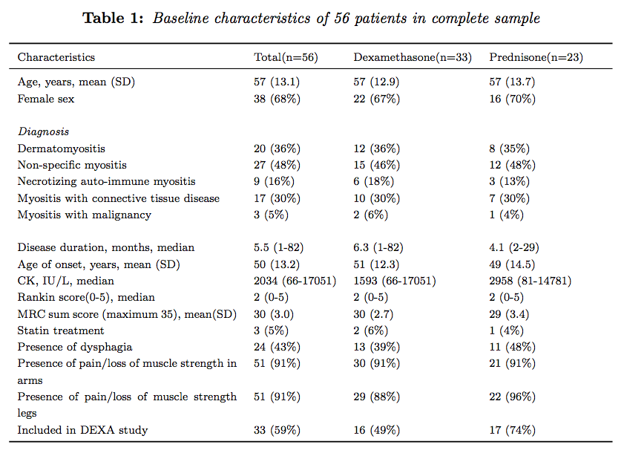Overall, 33 patients started the dexamethasone pulse therapy (six cycles at 28-days interval with 4 consecutive days of 40mg/day) and 23 patients started high-dose daily prednisone (40-80 mg/day). Treatment was started within 1 to 82 months after the onset of the disease (median 5.5). Twenty-three patients who did not participate in de dexa-myositis trial were included in the standard group, 17 were treated with dexamethasone pulse therapy and 6 were treated with prednisone. If the patient was already on prednisone this treatment was continued. Thirty-one patients had participated in the dexa-myositis trial and were included in the control group. Sixteen patients were treated with dexamethasone pulse therapy and 15 patients with prednisone.

Primary and secondary outcome measures in standard group
There was no significant difference between the dexamethasone (n=15) and prednisone group (n=4) in our primary outcome measure: the number of patients in remission after 1 year (p=0.91). In our secondary outcome measures, there was no significant difference in the mean MRC sum score after 1 year (p=0.75). There was a significant difference between the CK activities after 8-12 months in the two groups (p=0.05), those of the prednisone group being lower as compared to the dexamethasone group.
The number of patients without medication after 12 months did not differ statistically between the two groups (p=0.20). The number of treatment failures was also not statistically different (p=0.48). Table 2 shows the results of the secondary outcome measures in the standard group.
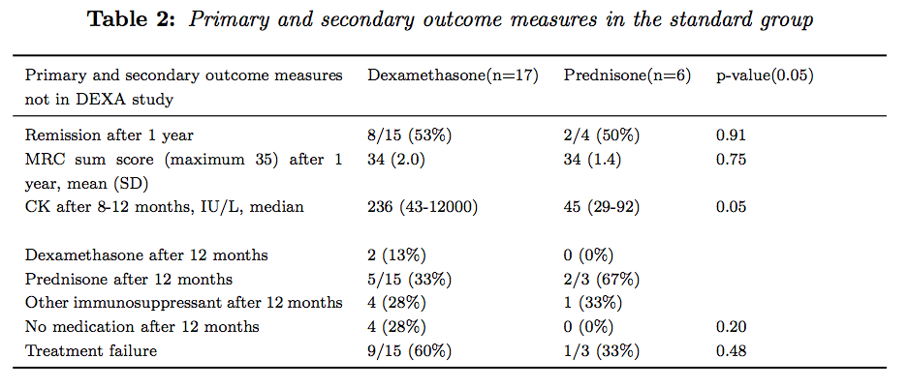

Side effects
The presence of any side effect did not differ significantly between the two groups in the standard group (p=0.43). Fourteen of 17 patients treated with dexamethasone (82%) experienced one or more adverse effects against four of 6 patients (67%) treated with prednisone. There were several different adverse effects (table 3). The sample size was too small to perform statistical calculations.

Primary and secondary outcome measures in complete sample
In our primary outcome measure, there was no significant difference in the number of patients in remission after 1 year between the dexamethasone and prednisone treated groups (p=0.46). For 2 patients the Rankin score was carried forward. There was also no significant difference in the mean MRC sum score after 1 year (p=0.26), and between the CK activities after 8-12 months in the two groups (p=0.12). There was too much missing data for the CK activities after 2-4 months and 4-6 months.
The number of patients that were without medication after 12 months was statistically larger in the dexamethasone group (p=0.01). The number of treatment failures was not statistically different (p=0.07). The median number of cycles dexamethasone before treatment failure was 3.5. Table 3 shows the results of the primary outcome measures in the complete sample.

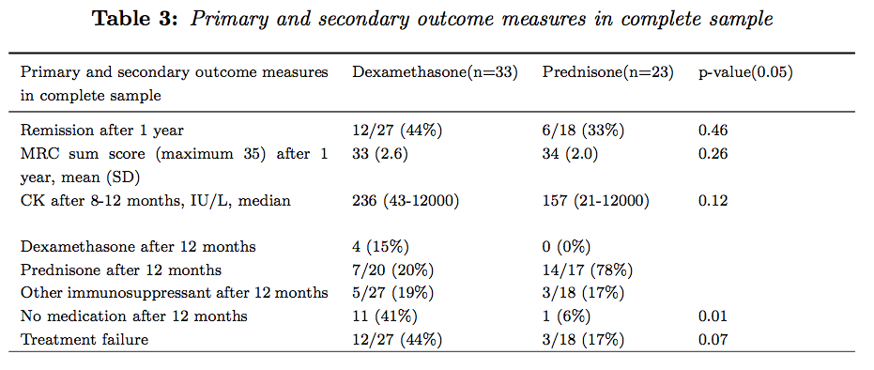
Side effects
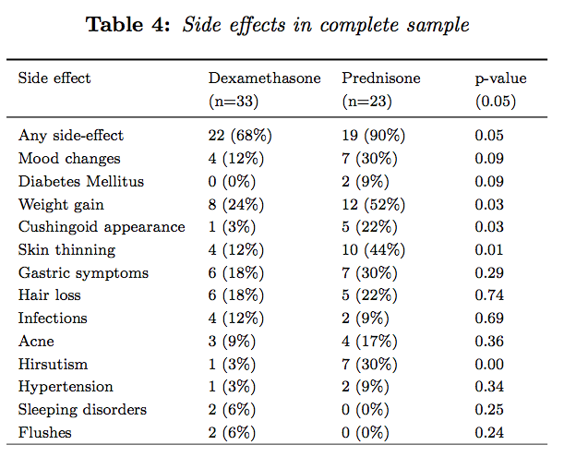 In the full sample the difference between the two groups was significantly less in the dexamethasone group (p=0.048). Of the 33 patients treated with dexamethasone, twenty-two (68%) experienced one or more adverse effect. In the prednisone group, nineteen of 21 patients (90%) treated experienced one or more adverse effect (see table 4).
4 Discussion
Implementation of dexamethasone as a first line treatment
Our study shows that in our third referral center high-dose dexamethasone pulse therapy (HD-DPT) was well implemented as first line therapy for the treatment of idiopathic inflammatory myopathies (inclusion body myositis excluded). We changed our policy after our group had demonstrated that HD-DPT is as effective as prednisone and has a more favourable profile of side-effects (11). Seventeen of the 23 patients that were diagnosed between 2008 and 2013 started HD-DPT as first line treatment. The only reason not to start with dexamethasone pulse therapy was if the patient was already being treated with prednisone, that had been prescribed elsewhere.

Primary and secondary outcome measures
We selected a clinically relevant clinical measure as primary outcome, i.e., the number of patients with remission after 12 months of treatment. A Rankin score of 0-1 out of 5 was considered a remission. Both the standard group and the complete sample did not show a statistical difference in Rankin score between the dexamethsone and the prednisone group. Neither, the mean MRC sum score after 1 year, a secondary outcome measure, showed a statistical difference.
Side effects were equally found in the dexamethsone and the prednisone group, but for the standard group the sample size was not sufficiently large to reliably perform a statistical test. However, in the complete sample, diabetes mellitus, Cushingoid appearance, skin thinning and hirsutism were more frequently found in the prednisone group. This would still imply that dexamethasone indeed has a more favorable side effect profile than prednisone, as was also demonstrated previously by us (11).

Dexamethasone as a firstline treatment
In the standard group we noticed that 4 out of 17 patients who were treated with dexamethasone did not use any medication after 12 months, compared to none of the 6 patients in the prednisone group, which was not statistically significant. However, in the complete sample 33% of the dexamethasone treated patients were free of medication as compared to 6% of the prednisone patients. These results seem to indicate that if the patient is submitted to dexamethasone therapy, he has a higher chance of being medication-free after 12 months than if the patient would have been treated with prednisone therapy. Admittedly this might partly be ascribed to the fact that with prednisone treatment tapering usually takes about a year after initiation of the treatment.
Dexamethasone therapy was not associated with significantly more frequent treatment failures albeit that in the complete sample 36% of the dexamethasone treated patients had to switch from dexamethasone to other steroids whereas in 17% of the prednisone group second line medication including azathioprine, methotrexate and IV immunoglobulin had to be added to the steroids or completely replace the steroid treatment. Approximately 18% of the patients, both in the dexamethasone and the prednisone group used other immunosuppressants after 12 months, including azathioprine, methotrexate and IV immunoglobulin. This indicates that for some patients neither dexamethasone nor prednisone alone is a sufficient therapy. We previously noticed that treatment failure is frequently occurring (11). Others confirmed our findings that corticosteroids as a monotherapy is not always sufficient for the treatment of patients with IIM (15). Well-designed clinical trials trials with other immunosuppressant medication or novel therapeutic agents are urgently needed (16) It is also of utmost importance to identify which patients are (partially) refractory to corticosteroid treatment.

Limitations
This study has a number of limitations. The retrospective design of the study limited the data collection. In addition, the low incidence of myositis also contributed to a small sample size. This hampered the statistical evaluation even more.

5 Conclusion
Dexamethasone pulse therapy has been implemented as the first line treatment for idiopathic inflammatory myopathies. For a proportion of myositis patients, dexamethasone is effective and safer than prednisone. However, more research needs to be done to improve treatment of patients with idiopathic inflammatory myoopathies .

6 References
1. Hak, A.E., de Paepe, B., de Bleecker, J.L., Tak, P.P., de Visser, M. Dermatomyositis and polymyositis: new treatment targets on the horizon. Neth. J. Med. 2011;69(10):410–21.
2. Gordon, P.A., Winer, J.B., Hoogendijk, J.E., Choy, E.H. Immunosuppressant and immunomodulatory treatment for dermatomyositis and polymyositis. In: The Cochrane Collaboration, Gordon PA, editors. Cochrane Database Syst. Rev. [Internet]. Chichester, UK: John Wiley & Sons, Ltd; 2012.
3. Bronner, I.M., van der Meulen, M.F.G., de Visser, M., Kalmijn, S., van Venrooij, W.J., Voskuyl, A.E., Dinant, H.J., Linssen, W.H., Wokke, J.H., Hoogendijk, J.E. Long-term outcome in polymyositis and dermatomyositis. Ann. Rheum. Dis. 2006;65(11):1456–61.
4. Drake, L.A., Dinehart, S.M., Farmer, E.R., Goltz, R.W., Graham, G.F., Hordinsky, M.K., et al. Guidelines of care for dermatomyositis. J Am Acad Dermatol. 1996;34(5 Pt 1):824–9.
5. Marie, I., Mouthon, L. Therapy of polymyositis and dermatomyositis. Autoimmun Rev. 2011;11(1):6–13.
6. Marie, I., Hachulla, E., Hatron. P.Y., Hellot, M.F., Levesque, H., Devulder, B., et al. Polymyositis and dermatomyositis: short term and longterm outcome, and predictive factors of prognosis. J Rheumatol. 2001;28(10):2230–7.
7. Rodeghiero, F. First-line therapies for immune thrombocytopenic purpura: re-evaluating the need to treat. Eur. J. Haematol. 2008 Jan 18;80:19–26.
8. Nakazaki, K., Hosoi, M., Hangaishi, A., Ichikawa, M., Nannya, Y., Kurokawa, M. Comparison between Pulsed High-Dose Dexamethasone and Daily Corticosteroid Therapy for Adult Primary Immune Thrombocytopenia: A Retrospective Study. Intern. Med. 2012;51(8):859–63.
9. Mashhadi, M., Kaykhaei, M., Sepehri, Z., Miri-Moghaddam, E. Single course of high dose dexamethasone is more effective than conventional prednisolone therapy in the treatment of primary newly diagnosed immune thrombocytopenia. Daru J. Pharm. Sci. 2012;20(1):7.
10. Hughes, R.A., Mehndiratta, M.M. Corticosteroids for chronic inflammatory demyelinating polyradiculoneuropathy. In: The Cochrane Collaboration, Hughes RA, editors. Cochrane Database Syst. Rev. [Internet]. Chichester, UK: John Wiley & Sons, Ltd; 2012.
11. Van de Vlekkert, J., Hoogendijk, J.E., de Haan, R.J., Algra, A., van der Tweel, I., van der Pol, W.L., et al. Oral dexamethasone pulse therapy versus daily prednisolone in sub-acute onset myositis, a randomised clinical trial. Neuromuscul. Disord. 2010;20(6):382–9.
12. Amato, A.A., Barohn, R.J. Evaluation and treatment of inflammatory myopathies. J Neurol Neurosurg Psychiatry. 2009;80(10):1060–8.
13. Tipping, C.J., Young, P.J., Romero, L., Saxena, M.K., Dulhunty, J., Hodgson, C.L. A systematic review of measurements of physical function in critically ill adults. Crit Care Resusc. 2012;14(4):302–11.
14. Quinn, T.J., Dawson, J., Walters, M.R., Lees, K.R. Reliability of the Modified Rankin Scale: A Systematic Review. Stroke. 2009 Aug 13;40(10):3393–5.
15. Mathur, T., Manadan, A.M., Thiagarajan, S., Hota, B., Block, J.A. Corticosteroid Monotherapy Is Usually Insufficient Treatment for Idiopathic Inflammatory Myopathy. Am J Ther. 2013; [Epub ahead of print]
16. Hoogendijk JE, Amato AA, Lecky BR, et al (2004). 119th ENMC international workshop: trial design in adult idiopathic inflammatory myopathies, with the exception of inclusion body myositis, 10-12 October 2003, Naarden, The Netherlands. Neuromuscul Disord 14: 337-345.

Number of patients in group deviates.
Number of patients in group deviates.
Number of patients in group deviates.
Number of patients in group deviates.

